WESTERN CAPE WATER SUPPLY SYSTEM
RECONCILIATION STRATEGY

Progress Report

of the

Strategy Steering Committee

November 2011

TABLE OF CONTENTS

Page No

1. INTRODUCTION 2
2. PROGRESS WITH IMPLEMENTATION OF THE STRATEGY 2
2.1 Strategy Steering Committee 2
2.2 Progress with implementation of WATER CONSERVATION / WATER DEMAND MANAGEMENT (WC/WDM) 2
2.3 Progress with Studies 4
3. 2011 strategy update 6
3.1 Current Water Requirements 6
3.2 Intervention Implementation Programme 8
3.3 Adjustments of the Strategy 8
4. Implementation of the Ecological Reserve 12
5. CONCLUSIONS 14
6. RECOMMENDATiONS 15

APPENDIX A: EXTENT OF WCWSS
APPENDIX B: REPRESENTATION ON STRATEGY STEERING COMMITTEE
APPENDIX C: IMPLEMENTATION PROGRAMMES

/tmp/in/input.doc\

INTRODUCTION

In early 2005, the then Department of Water Affairs and Forestry (DWAF), as the custodian of the country's water resources, in partnership with the City of Cape Town (CCT), commissioned the Western Cape Reconciliation Strategy Study to facilitate the reconciliation of predicted future water requirements with supply available from the Western Cape Water Supply System (WCWSS) for a 25-year planning horizon. The Strategy is used as a decision-support framework for making timeous and informed recommendations on those interventions that should be implemented to meet the future water requirements. The extent of the WCWSS is shown in Appendix A.

The Strategy was completed in 2007 and since then it has been reviewed and updated by the Strategy Steering Committee. This Progress Report provides an overview of the 2011 update to the Strategy.

PROGRESS WITH IMPLEMENTATION OF THE STRATEGY

Strategy Steering Committee

One of the recommendations of the Reconciliation Strategy Study was that a Strategy Steering Committee (SSC) be formed with a clearly defined mandate and scope of work.

The objectives of the SSC are:
• To ensure and monitor implementation of the recommendations of the WC Reconciliation Strategy,
To ensure that the necessary studies by the responsible institutions identified in the Strategy, are started timeously to ensure continued reconciliation of water supply and requirements
• To update the Strategy to ensure that it remains relevant, and
• To ensure that the Strategy, its recommendations and progress with the implementation are appropriately communicated to all stakeholders.

The SSC has met nine times since the Strategy was completed in May 2007. The Committee is functioning as it was intended and the stakeholders and water users of the WCWSS actively partake and provide feedback in the meetings. The list of SSC members is contained in Appendix B.

An Administrative and Technical Support Group (Support Group) was formed to support the SSC. The Support Group consists of inter alia representatives from the Department of Water Affairs’ National Office (Directorates of National Water Resource Planning, Water Resources Planning Systems and Options Analysis), the DWA Western Cape Regional Office and the CCT (Department of Bulk Water Supply and WC/WDM). The Support Group meets between the SSC meetings to ensure that the recommendations of the strategy and committee are implemented.

Progress with implementation of WATER CONSERVATION / WATER DEMAND MANAGEMENT (WC/WDM)

The CCT’s comprehensive 10-year WC/WDM Strategy and programme was approved by the Mayoral Committee in May 2007. The WC/WDM Strategy targeted water savings of approximately 90 million m³/a by 2016/2017. Since 2009 when the impact of the WC/WDM strategy was monitored, it has been evident that either the growth in actual water requirement was greater than that assumed in the High Water Requirement Curve, or that the CCT’s WC/WDM strategy was not achieving the targeted savings, or that a combination of these two factors was being experienced.

In the light of this, the CCT in 2011 started reviewing their WC/WDM savings targets for the next 10 years, as well as the associated budgetary requirements. Information on the updated savings targets and revised budgets will be available for the March 2012 Strategy Steering Committee Meeting. It was also agreed that the Strategy Steering Committee would wait for the latest Census figures to be released before recommending that the CCT initiate a study to review the assumptions contained in the development of the High Water Requirement Curve.

2.2.1 Progress with Initiatives

The CCT has focussed on a number of WC/WDM interventions during the 2010/2011 financial year. The following statistics summarise some of the achievements with the implementation of the Strategy and give an indication of the extensive WC/WDM measures which have already been implemented:

- Pressure Management was successfully implemented in Crossroads/Plumstead /Retreat/Marina Da Gama/Lavender Hill – Savings = 2.28 Ml/day
- 27 621 dysfunctional consumer water meters were replaced
- 95 users were supplied with Treated Effluent which accounts for 30 Ml/day of re-use (Potable Water replacement – 12.66Ml/day).
- ± 100 Caretakers were trained
- 60 Schools were visited and leaks repaired
- Awareness and Education 2 688 workshops
- Approximately 200 households visited for the Integrated Leaks Repair project.
- WDM flow limiting devices installed ± 9000.

2.2.2 CCT WC/WDM Budgets and Savings Achieved

The CCT has actively managed the WC/WDM Strategy budget and a number of budget revisions have been necessary throughout the last four years. In the first two years of implementation the CCT actually spent more on WC/WDM than what was required in the WC/WDM strategy. However, in the 2009/10 and 2010/11 financial year the CCT budget (and actual expenditure) was much less than the budgeted allocation in the approved Strategy. The approved WC/WDM budget for the 2011/12 financial year is also approximately half that of what is required in terms of the approved Strategy. Figure 1 below shows the original budget, amended budgets, the anticipated savings associated with the budgetary allocations and the actual savings achieved. It must be noted that the actual expenditure figure excludes pipe replacement expenditure and the actual expenditure given is therefore understated.

It is conservatively estimated, based on figures supplied by the CCT, that the CCT’s WC/WDM Strategy measures implemented have saved approximately 32.1 million m³/a over four years from 2007/08 through to 2010/11. This is approximately 58% of the targeted savings contained in the original 2007 WC/WDM Strategy for the same period. The estimated WC/WDM saving for the 2010/11 financial year is estimated to be 5.5 million m³/a. It must be noted that the actual savings are only shown for those WC/WDM savings which could be measured, and that additional non-quantifiable savings may also have been achieved.

The CCT is in the process of reviewing and revising the target savings and budgets contained in the 2007 WC/WDM strategy and programme. The revised targets and budgets will be available by March 2012 and will be presented to the planned March 2012 Strategy Steering Committee meeting.

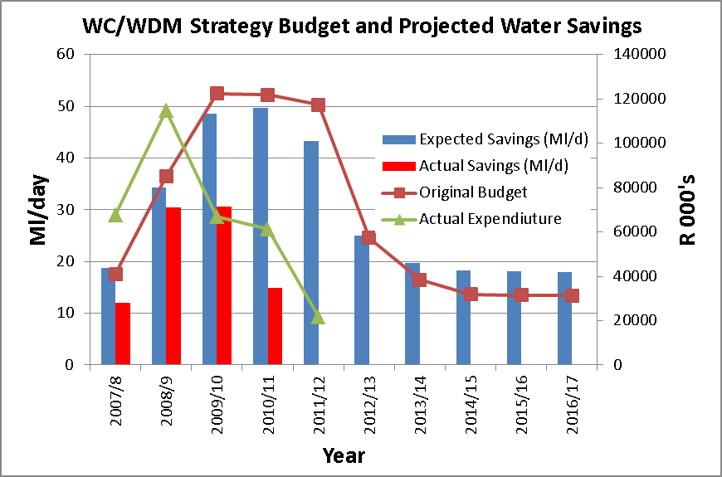

Figure 1: CCT WC/WDM Strategy: Budget, Expenditure and Savings

Progress with Studies

This section of the progress report details the progress the DWA and the CCT have made in the implementation of the supply-side interventions.

2.3.1 DWA Studies

The DWA, through the Directorate: Options Analysis is currently undertaking a full feasibility study to further investigate two potential surface water development options to augment the Western Cape Water Supply System. Each of these options is based on the diversion of surplus winter water into existing or new bulk storage facilities (dams). The schemes which are currently being studied are Voëlvlei Phase 1 and Michells Pass Diversion. The implementation of the latter augmentation option will be subject to water availability in the Breede River Basin.

A brief summary of the progress over the last year is highlighted below:
- There has been on-going development of the two proposed schemes’ (Berg River abstraction and Michell’s Pass Diversion) operating rules and EWR scenarios;
- Intensive public engagement has been necessary to obtain agreement for access to all affected properties for geotechnical investigations, design planning and for the EIA process (to be undertaken by others);
- The preliminary horizontal and vertical pipeline route options are complete and the weir design is in progress.
- Siting of the potential EWR Dam on the Boontjies River is complete. The necessary storage volume is being determined to provide for the summer EWR in the Breede, as well as for provision of summer irrigation water to existing users (Artois Canal Irrigators)
- The water quality dispersion modelling to assess the impact on Voëlvlei Dam water quality from Berg River winter abstraction is complete and the report is currently being prepared.
- The aerial survey and geotechnical investigations are complete.
- Significant effort, trouble-shooting and checking have been required for the migration of the yield and planning models from the previous DOS versions into the latest Windows-based versions. This has proved significantly more challenging and time consuming than was anticipated, but good progress has been made in this regard.

2.3.2 DWA’s Reconciliation Strategy Studies for All Towns

The All Town Reconciliation Strategies were completed and summary reports for each of the the District Municipalities as well as a Provincial Summary Report have been drafted. These reports will all be available on the DWA website under Reports.

2.3.3 CCT Studies

The exploratory phase of the CCT’s Feasibility Study and Pilot Project into the potential for developing the TMG groundwater aquifer has been completed and the CCT is currently reviewing all of the Exploratory Phase Reports. A decision on whether or not to proceed with the pilot phase of the project will be made by the Mayoral Committee of the CCT in the first quarter of 2102. Subject to this approval and the successful completion of the CCT’s pilot phase of the feasibility study, it is anticipated that the earliest implementation date of a full-scale production well-field would be in 2021.

The CCT has gone out to tender on a desalination feasibility study. It is anticipated that the study will commence early in 2012 and will be completed by the end of 2012. The CCT is also planning on initiating a water re-use feasibility study in early 2012. The re-use study would also be completed by the end 2012 or early 2013. It is important to note that whilst the Reconciliation Strategy may give guidance as to when the next augmentation scheme should be introduced (water balance at 98% supply assurance), in the case of desalination and re-use the integration into the WCWSS and associated risks of spillage and the introduction of a scheme with a 100% level of supply assurance may actually guide and dictate the implementation date, phasing and capacity of the implementation of desalination and re-use. The costs and associated yield would therefore be very dependent on integration into the WCWSS and the CCT’s Bulk Water Supply system.

It is anticipated that the feasibility study into the possible use of the Cape Flats Aquifer and Newlands Aquifer will commence towards the end of 2012. Due to human resource capacity and budget constraints the feasibility study on the development of the Lourens River Augmentation Scheme will only commence in 2013.

2.3.4 Other Municipalities

The Feasibility Study as well as the Implementation Readiness Study (IRS) for the proposed seawater desalination plant in the Saldanha Bay region was submitted by the West Coast District Municipality (WCDM) and approved by DWA. The Bulk Infrastructure Plan Funding and Implementation Agreement with DWA for the project was signed in August 2011 and the final approval of funds from the Regional Bulk Infrastructure Programme was issued by DWA on 1 September 2011. The funding was made available for the EIA of the desalination project and is subject to the condition that the study take into account and be aligned with the relevant “All Town Study” or any other relevant water resource planning studies being undertaken by DWA. It is anticipated that the feasibility study and EIA will be completed by April 2013. Should the design and construction go ahead, the desalination plant could be operational by September 2015.

It was reported that Drakenstein Municipality has a current unaccounted for water of 10.4%. The largest saving was accomplished by better pressure management, which reduced pipe bursts. Drakenstein Municipality are in the process of replacing asbestos pipes and 16 km were replaced in the 2010/11 financial year. It was noted that a choir from Drakenstein Municipality won the DWA 2010 WC/WDM choir competition and have recently compiled a CD with water conservation songs.

2011 strategy update

Current Water Requirements

For the purposes of reconciling water supply and requirement in the WCWSS, the water requirements for the period 2010/2011 were compared with the available supply. The actual sectoral water use pattern (based on releases from dams) in the WCWSS for 2010/11 was as follows:

Urban: 349.5 million m³/a (67% of the total)
Irrigation releases (Note1): 174.3 million m³/a (33% of the total)
TOTAL 523.8 million m³/a

Note 1: It must be noted that the agriculture sector did most probably not use the full 174.3 million m³ and it is anticipated that a significant amount of water released from the Berg River Dam and from Voëlvlei Dam was not abstracted by agriculture and ended up flowing into the Berg River estuary.

For planning purposes the actual water requirement for agriculture was “adjusted” to take into account the variability of rainfall, possible additional releases and the fact the agricultural sector can still grow into their capped allocation. It is important to use the “adjusted” total water requirement for planning purposes as it is in times of drought when the agricultural sector will maximise their water use from the WCWSS, as their farm dams may not be full. The “adjusted” total water use from the WCWSS is given below and also shown in Figure 2.

Urban: 349.5 million m³/a (68% of the total)
Irrigation estimated: 167 million m³/a (32% of the total)
TOTAL 517 million m³/a

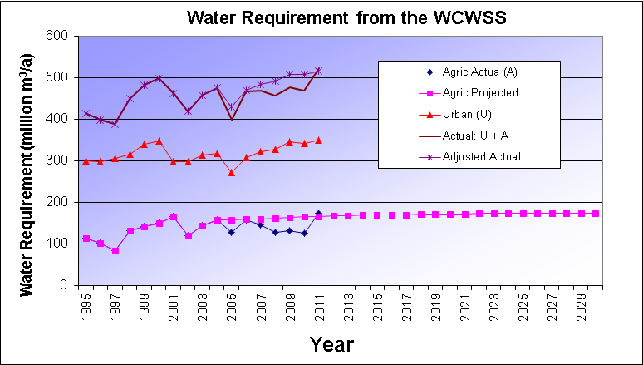

Figure 2: Water Requirements from the WCWSS

A Decision Support System (DSS) is currently being developed for the WCWSS. This will include a real-time monitoring to improve the management of releases from the major dams.

Water Balance

The Berg Water Availability Assessment Study recently completed by DWA showed that the integrated historical firm yield of the system remained unchanged. However the 1:50 year stochastic yield, determined with DWA’s Water Resource Planning Model (WRPM) showed that the sum of the increases of the standalone 1:50 year yields of the individual dams could result in a combined increase in yield of 26 million m³/a. This is however not the full yield of the system and an additional approximately 14 million m³/a is available if all the dams are managed and operated as a system so as to maximise the water resource situation at the end of winter each year. The updated total integrated system yield at a 98% level of supply assurance is therefore 596 million m³/a. The various components of the updated 1:50 year yield are shown in Figure 3 below.

A comparison between the adjusted total water requirement from the WCWSS and the high water requirement curves developed during the Reconciliation Strategy Study (refer to Figure 3) shows that the adjusted total water requirement falls just below the high water requirement curve.

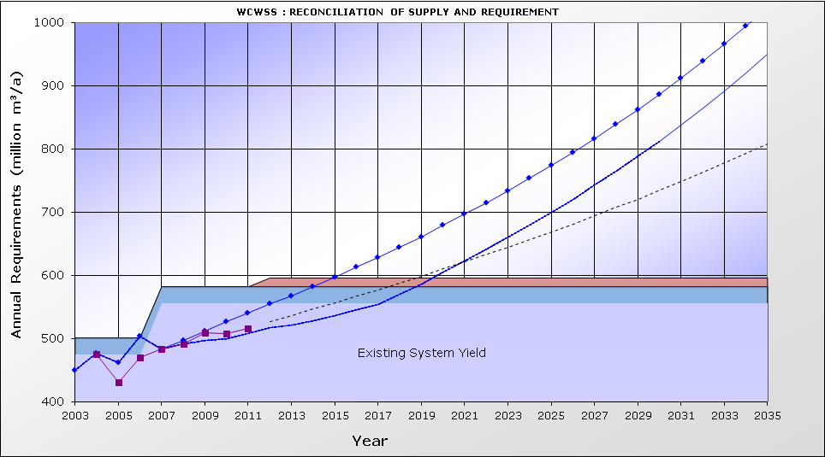
High Water Requirement Curve
Actual Water Requirement Curve
High Water Requirement Curve with WC/WDM
Optimised System yield
CCT growth: 2.4% p.a.
W Coast growth: 3.5% p.a.
WAAS: Updated 1:50 year yields
Figure 3: Total and Projected water requirement from the WCWSS

The adjusted total water usage from the WCWSS for 2011 is approximately 517 million m³/a, compared to the existing WCWSS available yield of 596 million m³/a. A future water requirement trend line is included in Figure 3, as a faint dotted line. This trend line depicts a continuation of the historic water requirement trend and is based on a growth in the water requirement of the CCT of 2.4% per annum and for West Coast District Municipality of 3.5% per annum. The agricultural water requirement was assumed to grow into its capped allocation of 174 million m³/a..

Intervention Implementation Programme

The updated implementation programmes for the Voëlvlei Phase 1 Augmentation Scheme, desalination, water re-use, and the TMG scheme are shown in Appendix C of this Report. The comparative fast-tracked programmes for these schemes are also shown in Appendix C. Fast-tracking an intervention could be achieved through either minimising the time taken by the approval processes, and/or running the environmental approval process and scheme design as parallel processes.

The construction programme for any of these interventions would be quite tight and is based on a number of construction activities being implemented in parallel.

Adjustments of the Strategy

In order to obtain a good understanding of the range of possible implementation dates of the next required supply-side intervention, three scenarios were developed taking account of updated water requirements, the potential effectiveness of implementing WC/WDM measures and achieving the targeted savings, potential climate change impacts, the current status quo of the feasibility studies, and implementation progress.

The following three scenarios were investigated:

- Scenario 1: 2011 Reference Scenario: Revised Integrated System Yield, “High water requirement”, CCT WC/WDM strategy 100% successful (2012 to 2017), no climate change
- Scenario 2: WC/WDM 50% successful: Revised Integrated System Yield, “High water requirement”, CCT WC/WDM strategy 50% successful (2012 to 2017), no climate change
- Scenario 3: “Worst-Case” Scenario: Revised Integrated System Yield, “High water requirement”, CCT WC/WDM strategy 50% successful (2012 to 2017) with possible effects of climate change.

Many more scenarios exist between the 2011 Reference Scenario and the “Worst-Case” Scenario, but if solutions could be found for these two scenarios, all others should be covered. Should the adjusted total water requirement follow a lower trajectory than the High Water Requirement Curve, then the required implementation date of interventions could be delayed and more options for implementation would become available to select from.

3.3.1 Scenario 1: 2011 Reference Scenario (“High water requirement”, WC/WDM 100% successful, no climate change effects)

The 2011 Reference Scenario assumes that the CCT is able to achieve its remaining year-on-year WC/WDM targets for the period 2013 to 2017, based on its WC/WDM Strategy and programme. As the CCT has determined anticipated savings for the 2011/2012 year based on already identified interventions and available capital budgets, the anticipated 2011/2012 savings were used in the analysis. The WC/WDM savings reported for the first four years (from 2007 to 2011) have been adopted as actual savings achieved. Under this scenario the requirement for water would exceed the available supply in 2020. The additional 1:50 year yield obtained from the Berg WAAS Study and the incremental system yield obtained if all the dams in the WCWSS are operated and managed as a system (optimising the yield) are also shown separately on Figure 4

A comparison between the adjusted total water requirement from the WCWSS and the available supply is shown in Figure 4 above.

The following interventions would be available for implementation by 2020:
- Voëlvlei Phase 1
- Water re-use
- Desalination of seawater.

The following interventions will not be available for implementation by 2019:
- Michell’s Pass Diversion – potentially subject to a Water Availability Assessment Study in the Breede River to determine the available yield
- Raising of Steenbras Upper Dam – much longer lead time required to implement
- TMG Aquifer – the TMG Aquifer has been identified as a potentially significant source of water for future supply to the WCWSS. It is however envisaged that any large-scale development of the TMG Aquifer will only occur upon completion of the CCT’s current initiative, once the feasibility and sustainability of large-scale abstraction for the WCWSS has been established. The earliest implementation date is currently estimated as 2021
- Development of the Lourens River Diversion, Cape Flats or Newlands Aquifer – not available for implementation by 2020 as the CCT, with its current limited human and financial resources, has decided to focus its attention on initiating water re-use and desalination feasibility studies as their first priority.

After the implementation of one of the three options by 2020, a whole range of options then become available to be implemented over time. A possible reconciliation of supply and requirement based on lowest Unit Reference Value (URV) is shown in Figure 4 below, taking into account those interventions that could potentially be implemented in time. This represents only one potential development sequence. Other potential development sequences could include seawater desalination.

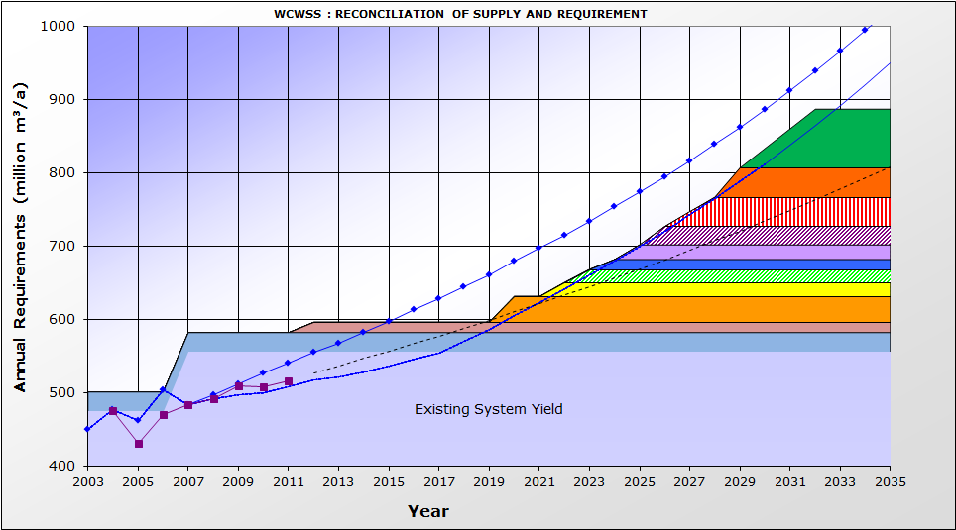
High Water Requirement Curve
Actual Water Requirement Curve
High Water Requirement Curve with WC/WDM
4
5
6
7
3
2
1
8
9
10
Figure 4: Reconciliation of Water Supply and Requirement for the 2011 Reference Scenario based on lowest URV

In Table 1 the interventions which have been used in Figure 4 are listed.
Intervention required by 2019

Table 1: 2011 Reference Scenario: Supply-side interventions that could be implemented

No | Intervention | Year of First  Water | Yield  (million m³/a) | Fast-  tracked  9  10  8  7  1  6  2  4
1 | Optimise System Operation | 2012 | 14 | No
2 | Voëlvlei Phase 1 | 2020 | 35 | No
3 | Lourens | 2022 | 19 | No
4 | Cape Flats Aquifer | 2023 | 18 | No
5 | DWA:ASR: West Coast | 2024 | 14 | No
6 | TMG Scheme 1 | 2025 | 20 | No
7 | Raise Lower Steenbras | 2026 | 25 | No
8 | Re-use Generic 1 | 2027 | 40 | No
9 | Re-use Generic 2 | 2029 | 40 | No
10 | Desalination | 2030 | 80 | No

It is important to note that the implementation dates almost follow year-on-year, due to the relative small yields of the different schemes.

3.3.2 Scenario 2: WC/WDM 50% successful (“High water requirement”, WC/WDM 50% successful, with no climate change effects)

This Scenario assumes that the CCT is only able to achieve 50% of its remaining year-on-year WC/WDM targets for the period 2012 to 2017, based on its WC/WDM strategy and programme. Under this scenario the requirement for water would exceed the available supply in 2019.

A possible reconciliation of supply and requirement for the WC/WDM 50% successful Scenario is shown in Figure 5. This represents only one potential development sequence.

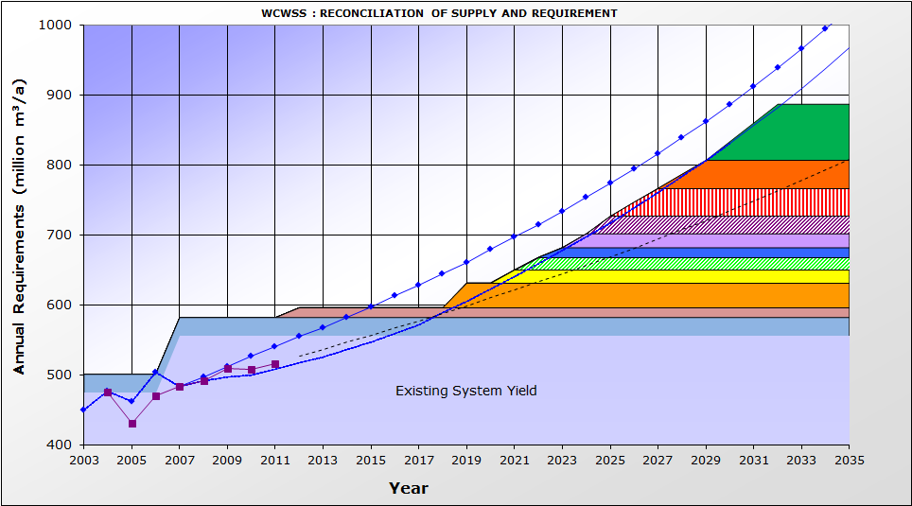
High Water Requirement Curve
Actual Water Requirement Curve
High Water Requirement Curve with WC/WDM
4
5
6
7
3
2
1
8
9
10

Figure 5: Reconciliation of Water Supply and Requirement under a 50% successful WC/WDM scenario

Table 2 lists the supply-side interventions which have to be implemented in order to ensure the reconciliation of supply and requirement up to 2035 under this scenario.

Table 2: 50% Success with WC/WDM: Supply-side interventions implemented
No | Intervention | Year of First  Water | Yield  (million  m³/a) | Fast-  tracked
1 | Optimise System Operation | 2012 | 14 | Yes
2 | Voëlvlei Phase 1 | 2019 | 35 | No
3 | Lourens | 2021 | 19 | No
4 | Cape Flats Aquifer | 2022 | 18 | No
5 | DWA:ASR: West Coast | 2023 | 14 | No
6 | TMG Scheme 1 | 2024 | 20 | No
7 | Raise Lower Steenbras | 2025 | 25 | No
8 | Re-use Generic 1 | 2026 | 40 | No
9 | Re-use Generic 2 | 2028 | 40 | No
10 | Desalination | 2030 | 80 | No

3.3.3 Scenario 3: “Worst-Case Scenario” (“High water requirement”, WC/WDM 50% successful, with potential climate change effect)

The Worst-Case Scenario assumes that the CCT is only able to achieve 50% of the remaining total WC/WDM target proposed in the 10-year WC/WDM Strategy and Programme. This scenario also assumes that climate change will impact on the available yield of the WCWSS. Under this scenario the requirement for water would exceed the available supply in 2019.

Based on more recent studies undertaken for impacts of climate change on the Western Cape Water Supply System, it has now been assumed that that the available yield of existing and future surface water interventions would negatively decrease by approximately 5% over the next 25 years. This translates to a decrease in yield of approximately 1 million m³/a or 15 million cubic metres of water per annum over a 25 year period. According to climatologists, the global climate change models predict that there could be a mean long-term trend for drying in the Western Cape (with less certainty in the mountains). It is further anticipated that more frequent intense rainfall events may occur. Whilst there is a general acceptance that climate change is occurring, the long-term rainfall records at Wemmershoek and Steenbras dams do currently not yet show any evidence of significant short-term or long-term variance in annual rainfall patterns.

It would be very costly to implement additional interventions to offset the potential decrease in yield as a result of climate change. Interventions should therefore only be implemented if proof of a long-term decrease in rainfall were to be found. It is therefore important to monitor for any trend changes in rainfall and run off and to understand the possible impacts of climate change on water requirements. A possible reconciliation of supply and requirement for the Worst-Case Scenario is shown in Figure 6. This represents only one potential development sequence.

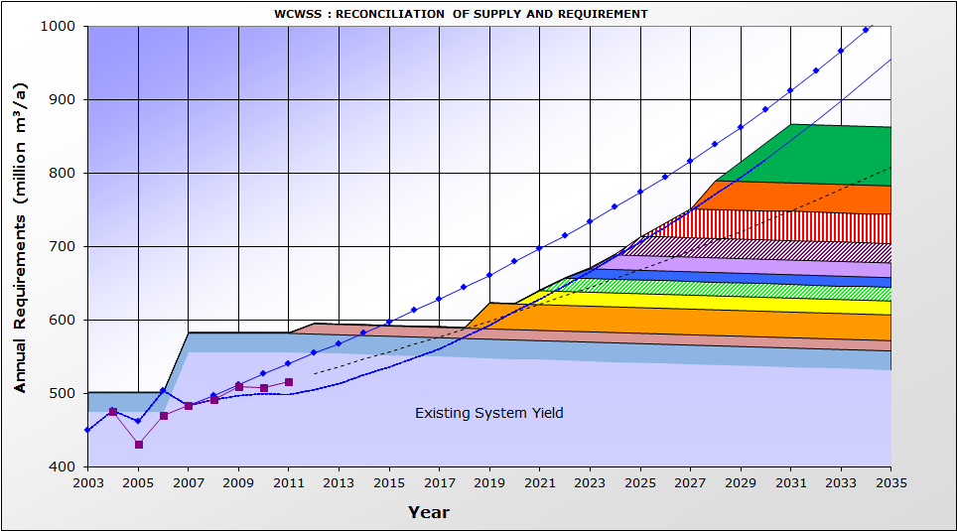
High Water Requirement Curve with WC/WDM
4
5
6
7
3
2
1
8
9
10
High Water Requirement Curve
Actual Water Requirement Curve
Figure 6: Reconciliation of Water Supply and Requirement for the Worst-Case Scenario to offset the potential impacts of Climate Change

Table 3 lists the supply-side interventions which have to be implemented in order to ensure the reconciliation of water supply and requirement up to 2030 for the Worst-Case Scenario.
4
5
6
7
3
2
1
8
9
10

Table 3: “Worst Case” Scenario: Supply-side interventions to be implemented
No | Intervention | Year of First  Water or Saving | Yield  million  m³/a | Fast-  tracked
1 | Optimise System Operation | 2012 | 14 | Yes  4  5  6  7  3  2  1  8  9  10
2 | Voëlvlei Phase 1 | 2019 | 35 | Yes
3 | Lourens | 2021 | 19 | No
4 | Cape Flats Aquifer | 2022 | 18 | No
5 | DWA:ASR: West Coast | 2023 | 14 | No
6 | TMG Scheme 1 | 2024 | 20 | No
7 | Raise Lower Steenbras | 2025 | 25 | No
8 | Re-use Generic 1 | 2026 | 40 | No
9 | Re-use Generic 2 | 2028 | 40 | No
10 | Desalination | 2029 | 80 | No

Implementation of the Ecological Reserve

The ecological Reserve requirement of the Berg River downstream of the Berg River Dam was built into the design and operational rules for the scheme. Dams constructed prior to the Berg River Dam are not yet releasing the ecological Reserve requirements. Based on the 2011 Reference Scenario, it is proposed that the ecological Reserve on “old dams” should only be phased in after 2019 or when a new augmentation intervention has been put in place. Should the Reserve be implemented prior to 2019, it would not be possible to implement interventions to offset the loss in yield due to the required environmental flow releases. The implementation of the Reserve should be phased in, in a planned manner, based on the implementation dates of future water augmentation schemes. Figure 7 illustrates a possible scenario for the implementation of the Reserve after 2019.

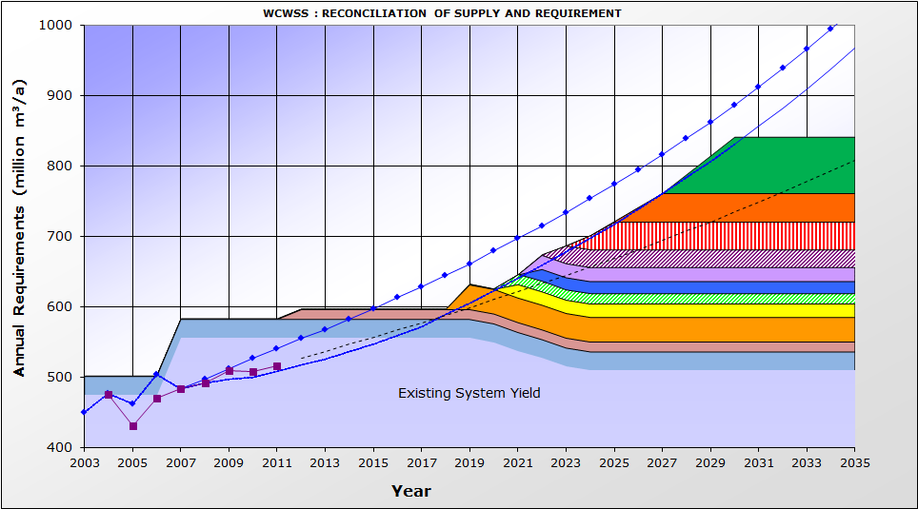
High Water Requirement Curve
Actual Water Requirement Curve
High Water Requirement Curve with WC/WDM
4
5
6
7
3
2
1
8
9
10

Figure 7: Reconciliation of water supply and requirements with phasing in of the ecological Reserve on “old” dams

Table 4 lists the supply-side interventions which have to be implemented in order to ensure the reconciliation of supply and requirement up to 2035, should the ecological Reserve be implemented.

Table 4: Ecological Reserve implementation Scenario: Supply-side interventions implemented
No | Intervention | Year of First  Water or Saving | Yield  million  m³/a | Fast-  tracked
1 | Optimise System Operation | 2012 | 14 | No
2 | Voëlvlei Phase 1 | 2019 | 35 | No
3 | Lourens | 2021 | 19 | No
4 | DWA:ASR: West Coast | 2021 | 14 | No
5 | Cape Flats Aquifer | 2022 | 18 | No
6 | TMG Scheme 1 | 2022 | 20 | No
7 | Raise Lower Steenbras | 2023 | 25 | No
8 | Re-use Generic 1 | 2024 | 40 | No
9 | Re-use Generic 2 | 2026 | 40 | No
10 | Desalination | 2028 | 80 | No

CONCLUSIONS

The following conclusions can be drawn from the 2011 scenario planning and strategy update:

- The successful implementation of WC/WDM by all users in the System remains absolutely critical to ensure the ongoing reconciliation of supply and requirements.
- There is uncertainty regarding future CCT WC/WDM savings. It is important for the CCT to review and revise the target savings and budgets contained in the 2007 WC/WDM strategy and programme. The outcome of the revision should be a revised 10-year programme to be accepted and adopted by the CCT. The revised targets and budgets need to be available before March 2012 so that the new figures can be presented at the scheduled March 2012 Strategy Steering Committee meeting.
- Since 2009 when monitoring of the impact of the WC/WDM strategy was measured, it has been evident that either the growth in actual water requirements was greater than that assumed when developing the High Water Requirement Curve, or that the CCT’s WC/WDM strategy was not achieving the targeted savings, or that a combination of these two factors was being experienced. It is proposed that the Strategy Steering Committee wait for the latest population Census figures to be released before recommending that the CCT initiate a study to review the assumptions contained in the development of the High Water Requirement Curve.
- The additional 1:50-year yield which became apparent through the Berg WAAS shows that the implementation of the next intervention could be delayed by approximately 2 years. This gain would be largely offset if the CCT is not able to meet its WC/WDM targets which were set in their 2007 approved 10-year WC/WDM strategy and programme.
- On account of the increased system yield (determined as an outcome of the Berg WAAS), it should not be necessary to fast-track a supply-side intervention to be implemented by the end of 2017, and to make a decision on this fast tracking in March 2012.
- Feasibility studies are being undertaken by both the Department of Water Affairs and the City of Cape Town to determine which of the three potential augmentation interventions that are on the table should be implemented by 2019, and the possible sequence of the interventions. A decision on which of these interventions to implement first will have to be made at the March 2013 meeting of the Strategy Steering Committee.
- The choice of which intervention to implement will be dependent on the growth in water requirements. If the growth in water requirements is lower than the high water requirement curve, then it may be possible to implement the intervention with the lowest URV, namely development of the Lourens River Augmentation Scheme. If the water requirements continue to grow at the current rate, it is important to continue with feasibility studies for other interventions as well.
- The Decision Support System (DSS) which is currently being developed for the WCWSS will include a real-time monitoring system and this should improve the management of releases from the major dams to also reduce potential losses incurred under current operating rules.
- It is important to implement a system to monitor potential indicators of climate change and to monitor the CCT’s success in implementing their WC/WDM Strategy measures.
- There is uncertainty surrounding the actual extent of invasive alien plant infestation in the catchment areas of the dams of the WCWSS and this need to be addressed by Working for Water. Clearing of the riparian zones of invasive plants is also seen as a potential way of making some water available to meet ecological water requirements.

RECOMMENDATIONS

The following recommendations follow from the assessment of the current water requirements and updated scenario planning:

- The CCT must actively continue with the implementation of its approved 10-year WC/WDM Strategy.
- The CCT needs to update their Strategy and confirm their anticipated WC/WDM savings for the next 10-year period and to ensure that sufficient budgets are allocated to be able to implement identified WC/WDM interventions identified and meet the set targets. The revised 10-year WC/WDM savings and budgets should be presented at the March 2012 Strategy Steering Committee Meeting in order to ascertain the impact on the updated Reconciliation Strategy.
- Regular reviews of the WC/WDM Strategy should be undertaken in order to ensure the objectives and targets set by the Strategy are achieved.
- The assumptions made in the 2007 Reconciliation Strategy in terms of population growth projections, economic growth projections and anticipated service delivery programmes should be reviewed and updated in order to ascertain whether the assumptions surrounding the development of the 2007 High Water Requirement Curve are still valid. The assumptions upon which the High Water Requirement curve was based should be reviewed when the latest population Census figures are released.
- The Feasibility Studies identified in the 2007 Reconciliation Strategy Study and the 2011 Scenario Planning update need to continue or start, namely:
  - Voëlvlei Phase 1 and Michells Pass Diversion Schemes – DWA to continue
  - Raising of Steenbras Lower Dam – DWA/CCT to commence with feasibility study
  - Table Mountain Group Aquifer (TMG) development – CCT to take decision on whether to proceed with the Pilot Phase of the project
  - Cape Flats and Newlands Aquifer development – CCT to start study by end 2012
  - Lourens River Dam - CCT to start study in 2013
  - Water Re-use – CCT to commence with feasibility study early in 2012
  - Desalination of seawater – CCT to commence with feasibility study early in 2012
  - Clearing of invasive alien vegetation - on-going and extent could be increased
- A monitoring system must be put in place to serve as an early warning that climate change has started to impact on water availability and/or water requirements.
- The Reconciliation Strategy for the Western Cape Water Supply System should be re-assessed in September 2012 and adjusted if required.
REFERENCES

DWAF, 2007. Western Cape Reconciliation Strategy Study.

DWA, 2009. Western Cape Water Supply System, Reconciliation Strategy, Status Quo Report, December 2009.

City of Cape Town, 2010. Progress with Implementation of the Long Term Water Conservation and Water Demand Management Strategy, Assessment, Summary Report, September 2010.

DWA, 2010. Western Cape Water Supply System, Reconciliation Strategy, Progress Report, October 2010.

Appendix A

EXTENT OF WCWSS

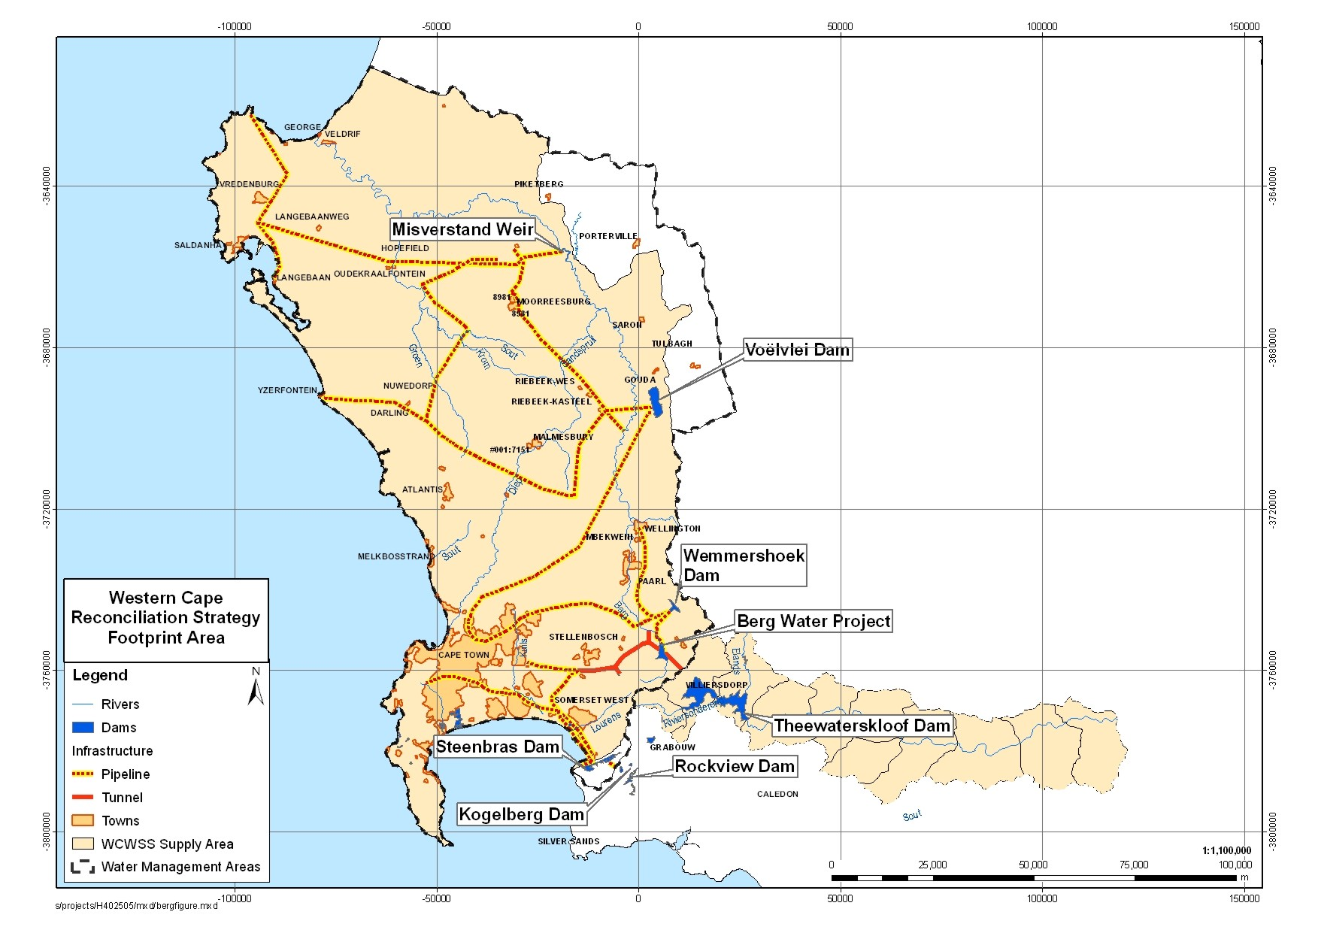

Appendix B

REPRESENTATION ON STRATEGY STEERING COMMITTEE

WESTERN CAPE STRATEGY STEERING COMMITTEE REPRESENTATION

ORGANISATION | ADDRESS
National Government
Department of Water Affairs (Head Office) | Private Bag X313, Pretoria 0001
Department of Water Affairs (Regional Office) | Private Bag X16, Sanlamhof 7532
Western Cape Provincial Government
Department of Agriculture | P/Bag X1 Elsenburg 7607
Department of Local Government and Housing | P/Bag X9083 Cape Town 8000
CapeNature | P/Bag X29 Rondebosch 7701
Dept of Environmental Affairs and Development Planning | P/Bag X9086, Cape Town 8000
- Planning Branch
- Environmental Branch
Local Authorities
City of Cape Town | PO Box 16548 Vlaeberg
- Bulk Water
- Waste Water
- WC/WDM
West Coast DM | PO Box 242, Moorreesburg 7310
Cape Winelands DM | PO Box 91, Worcester 6849
Drakenstein LM | PO Box 1, Paarl, 7620
Stellenbosch LM | PO Box 17, Stellenbosch
Witzenberg Municipality
CMAs
Berg | Not yet established
Breede-Overberg | Private Bag X3055 Worcester 6850
WUAs
Berg WUA | PO Box 540, Wellington 7655
Breede and Overberg WUAs | PO Box 232, Robertson 6705

Appendix C

INTERVENTION IMPLEMENTATION PROGRAMME

